# Arduino Cubcar / Pinewood Derby Timer

# Instruction Guide

V 10.0

The Arduino powered CubCar Timer is designed to run stand-alone (ie. Not connected to a PC)

This timer utilized a readily available Arduino Nano to provide the processing.

Results of the race are shown in the LED bank above the timer and simultaneously displayed on the attached LCD display.

The timer requires the following external connections:

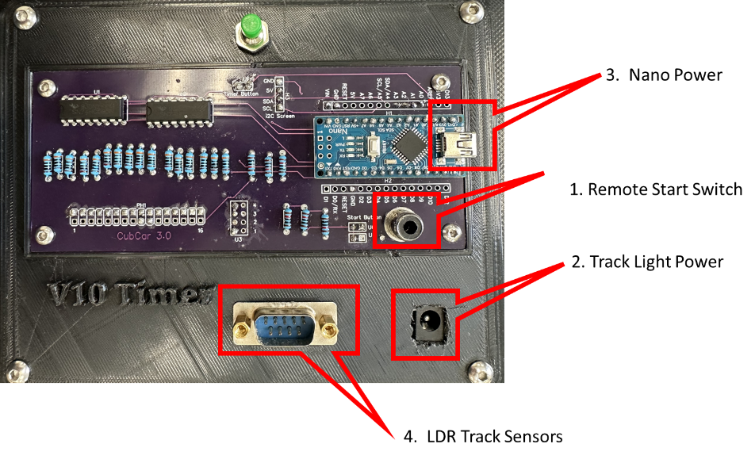

1. Remote Start Switch – Which is connected to the top of the track via the RCA connector on back of the timer.
2. Track Light Power – Which is provided via a barrel power connector found at the back of the timer. The power supply for the Track Lights must provide between 5-9 Volts DC
3. Arduino Power – Which is provided by a Micro USB cable connected though a USB power brick. Note: Some power bricks are intended for trickle charging a phone, not powering a USB device. If the timer is not functioning properly (Screen cant be read, LED bank dim etc.) then this is the likely culprit.
4. LDR track sensors – These are connected via a DB9 connector found at the back of the timer. These connect the embedded sensors in the track to the timer.

When setting up the timer ensure that the track lights provide consistent lighting over the track sensors. You may need to slide the timer around to ensure consistent lighting.

The track sensors rely on the shadow of a car being cast over them in order to trip. In a very bright room, or a room where there is additional light coming in which is not directly overhead this can result in the sensors not being able to detect the shadows of cars.

After making all the physical connections, plug in the timer and it will begin its startup sequence.

The track should be lit by the track lighting and the LEDs at the top of the timer will do two passes through each LED lighting each one individually.

## Startup Process

After each power up the Timer requires that it be tuned for the brightness of the room. You know the timer is in the tuning mode when the following happens:

First bank of LEDs lights up.

Make sure that the track light is on, and that there is nothing which is shading any of the track sensors. Press and release the timer button at the back of the timer.

Now the 2nd bank of lights on the timer will light up (as shown) and you can move to the 2nd step of tuning the start. The screen will display the following:

Put one cubcar on each lane with just the nose of each car shading the track sensor. Then once all the lanes are filled press and release the timer button again and the last bank of LEDs will light up.

The last screen shown is an information screen which will show the “Trip light value” for each lane.

You can now close the gate at the top of the track and start racing.

## **Start the Race:**

- The race begins when the start gate is released.

- The timers start, and the race times are displayed on the LCD as cars finish.

## **Race Results:**

- The LEDs will indicate the winner and the finishing order.

- The LCD displays the individual race times for each lane, with the winner indicated.

## **End of Race:**

- After all cars finish, or if the race times out, the LCD will display "Push Timer Button".

- Race timeout is set for 15 seconds so if all cars have not finished by then they will be timed as DNF.

- Press the Timer Button to reset the system for the next race.

Do not reset the start gate until after the last race has fully finished and the timer button has been pressed and released.

## Recommended Operation

Best way to use the track is to have two people who are manning the track, one at the start and one at the timer. Good communication is needed between the two people running the track to ensure that operations happen in the correct sequence. (Most common problem is that the top gate is closed too soon and the timer does not recognize that the gate has been closed). The top gate should not ever been closed until the screen at the bottom says “close Starting Gate”

## ## Troubleshooting

### - **Not reading Start Gate**

Most common cause for this is the person at the top of the track is closing the start gate too soon. The gate at the top should NOT be closed until after the last racer has passed the finish line and the timer reset button is pressed.

### - **Inconsistent LDR Readings:**

- Ensure consistent overhead lighting.

- Recalibrate the LDRs by restarting the timer (unplugging and plugging back in) if readings are inconsistent.

### - **Power Issues:**

- Ensure the Buck converter and power supply provide sufficient power.

- Avoid using a laptop's USB port for power.

### - **Button Malfunction:**

- Check connections and debounce settings for the Timer and Start buttons.

### - **Not Reading Specific Cars**

- This occasionally can happen if the cars have a very light underside, have hollowed out interiors, cars are very narrow, etc. Ways to fix for this is to put a small piece of black duct tape on the bottom of the car, or paint underside in a matte black finish.

### ## Maintenance

- Regularly check connections and ensure components are securely attached.

- Recalibrate LDRs periodically or if the lighting conditions change.